**CHAPTER-1**

**1.1-Introduction**

The Cycloidal Gear Drives are also called as Cycloidal Speed Reducer Mechanism are used in the reduction of speed of the input shaft that is been used in the system which helps in increase in the Torque and Load carrying capacity. These are better meant for better torque transmission than the other gear drives.

These cycloidal gear drives are used as they produce negligible amount of backlash that leads in ensuring the smooth operation, having high precision and accuracy.

Some key components and considerations typically involved in Cycloidal gear drive:

1. Input Shaft: This is the main input module which rotates at high speeds and which is generally been reduced to a lower speed.
2. Cycloidal Discs: These are generally considered the main or key components of the drive that helps in generating in the cycloidal motion and their profiles are designed to ensure efficient and smooth power transmission.
3. Intermediate disc: This disc actually acts like a connecting disc or this is placed in between the two cycloidal discs for transmitting the power.
4. Bearings: Robust bearings support the eccentric cam and cycloidal disc, ensuring stability and durability under high loads.
5. Reduction Ratio: Cycloidal drives are known for achieving high reduction ratios in a compact design, making them suitable for precision applications. Here we will be able to achieve the reduction ratio of 100:1.
6. Compact and robust design: The drive's compactness and ability to handle shock loads make it ideal for industrial machinery and robotics.
7. Least Backlash: Cycloidal drives offer minimal backlash and high efficiency, providing accurate and reliable performance in demanding conditions.

# 1.2-Objectives

# The primary objective of a cycloidal gear drive is to achieve efficient and precise speed reduction while delivering high torque in a compact and robust design. It uses a unique mechanism where cycloidal discs engage with output pins to ensure smooth power transmission, minimal backlash, and accurate motion control. This makes cycloidal drives highly reliable for applications that require precision, durability, and the ability to handle high shock loads. Their versatility and efficiency make them ideal for robotics, industrial machinery, and other demanding automation systems where performance and compactness are crucial.

**Key Objectives:**

1. *High Torque transmission:* High Torque Transmission Cycloidal gear drives are engineered to deliver high torque output efficiently, utilizing their unique gear profile to distribute load evenly across multiple contact points, reducing stress and enhancing power transfer.
2. *Precision and Smooth operation:* Precision and Smooth Operation With minimal backlash and smooth rotational motion, these drives are ideal for applications requiring precise positioning and motion control, such as robotics, CNC machines, and automated systems.
3. *Compactness and Durability:* Compactness and Durability Designed to be compact yet robust, cycloidal gear drives can handle heavy shock loads and provide long-term reliability in demanding environments, making them suitable for industries like aerospace, manufacturing, and heavy machinery.

# 1.3-Components

# Motor Shaft

# Input flange

# Cycloidal Disc 1

# Intermediate Disc

# Cycloidal Disc 2

# Eccentric Cams

# Bearings

# Roller pins

# Sleeve rings

# Fasteners

# Output flange

# Casing

# Fig. No. 1.3.1

**1.4- Methodology**

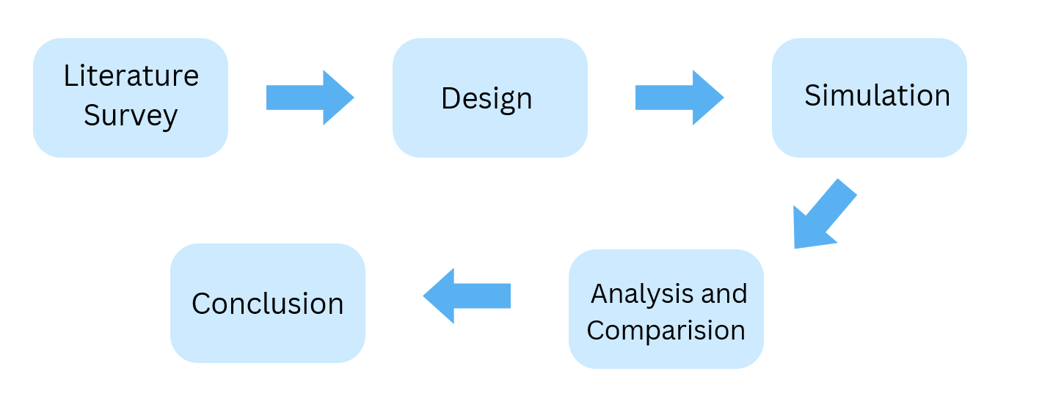

**Fig 1.4.1**

*Literature Survey:* We conduct extensive research into the casting process across various industries, including film, television, advertising, and theater. They analyze existing workflows, pain points, and opportunities for improvement.

*Design:* Based on the research and requirements, developers create prototypes and design mockups of the software interface, focusing on user experience, usability, and accessibility.

*Analysis and Simulation:* The analysis and simulation of a cycloidal gear drive involve studying its kinematic behavior, stress distribution, and efficiency using computational tools to optimize its performance and reliability in mechanical systems.

*Conclusion:*A dual-stage cycloidal gear drive offers high efficiency, compact design, and excellent torque transmission with minimal backlash, making it ideal for precision applications. Its robust construction ensures durability and reliable performance in demanding environments.

**CHAPTER-2**

**2.1- Literature Review**

1. Characteristics and Parameters of Cycloidal Gear Drive

A.N Sobolev and A.Y Nekrasov

Year: 2018

This paper is mainly focused on the study on Cycloidal Drives, the number of stages

that it can be worked on and the characteristics and parameters of the drives including

the reduction ratios.

2. Theoretical and Experimental Study for an Improved Cycloidal Drive Model

Jean-Luc Dion and Nicolas Peyret.

Year: 2020

This study presented in this paper mainly focused on the single stage Cycloidal Drive

For helping out in speed reduction and increase in the torque. This paper effectively predicted the performance of cycloidal drives across various conditions, instances and materialistic characteristics.

3. Design and Development of a Cycloidal Gear Drive for Speed Reduction

Carlo Gorla, Piermaria Davoli

Year: 2021

This study presented from this paper has been mainly focused on Single and Double stage systems, efficient for speed reduction and torque amplification in single. This paper explained optimized designs enhance efficiency and torque amplification.

4. Computational Studies on Cycloidal Gearboxes: A Systematic Literature Review

M. D. Seidel, M. R. Hansen, and J. R. R. A. Martins   
Year: 2021   
This systematic review explores the application of numerical simulations in the design and optimization of cycloidal gearboxes. The authors evaluate various computational techniques, such as finite element analysis (FEA) and multibody dynamics, to determine their effectiveness in predicting key performance metrics including stress distribution, vibration, and overall efficiency.

5. Dynamic Analysis of a Cycloidal Gearbox Using Finite Element Method

Authors: S. Thube and P. Bobak   
Year: 2015   
This study focuses on a dynamic analysis of a cycloidal gearbox through the finite element method (FEM). The authors create a three-dimensional numerical model to examine the gearbox's dynamic behaviour under operational loads. Significant findings reveal insights into stress concentrations, potential failure points, and the overall dynamic response of the gearbox. The research highlights the importance of FEM in predicting performance outcomes and enhancing the design of cycloidal gearboxes for industrial applications.

6. Study of the Transmission Characteristics of the Cycloid Gear Based on a Multi-Objective Optimization Modification Method

Y. Zhang, X. Li, and Z. Wang   
Year: 2023   
This research introduces a multi-objective optimization approach aimed at improving the transmission characteristics of cycloidal gears. The authors concentrate on minimizing transmission errors and optimizing load distribution by modifying gear profiles. Through a blend of theoretical analysis and numerical simulations, the study demonstrates that this optimization method significantly enhances gear performance, leading to reduced vibration and improved efficiency.

7.Design and Development of Cycloidal Gear Box

S. S. Patil, S. S. Kulkarni, and S. R. Kulkarni   
 Year: 2023   
This research investigates the design and development of a cycloidal gearbox, highlighting its benefits compared to traditional gear systems. The authors outline the design methodology, material selection, and manufacturing processes while emphasizing the gearbox's compact size, high torque capacity, and efficiency. The study illustrates the potential applications of cycloidal gearboxes across various mechanical systems, showcasing their advantages in load distribution and durability.

8.Cycloidal Gearboxes: A Game Changer?

J. Smith and A. Johnson   
 Year: 2015   
This article discusses the potential of cycloidal gearboxes as viable alternatives to conventional harmonic drives in robotics. The authors analyse the design principles, operational advantages, and challenges associated with cycloidal gearboxes, noting their robustness, compactness, and simplicity. Insights into practical considerations for implementing cycloidal drives in robotic applications are provided, including issues related to backlash, efficiency, and manufacturing ease.

9. Worm Drive vs. Cycloidal Drive

M. Brown and L. Davis

Year: 2019   
This comparative study assesses worm drives against cycloidal drives, focusing on their applicability in robotic systems. The authors examine the mechanical pros and cons of each type, considering efficiency, robustness, design complexity, and specific application scenarios. The analysis concludes that cycloidal drives generally outperform worm drives in terms of compactness and load handling capabilities, making them preferable for certain robotic applications.

**CHAPTER-3**

**3.1-Prior-art search**

*1. Compact Multi-Stage Reduction*

* Key Idea: Combining two cycloidal reduction stages in a single housing to achieve higher gear ratios without significantly increasing the overall size.
* Advantages:
  + High torque transmission in a compact space.
  + Greater gear reduction while maintaining smooth operation.
* Examples:
  + US4251987A (1981): Multi-stage cycloidal drive with efficient coupling between stages for industrial applications.

*2. Precision Robotics*

* Key Idea: Two-stage cycloidal drives are frequently used in robotics for their precision and low backlash.
* Innovations:
  + Use of needle bearings to minimize energy loss and wear.
  + Reduction of backlash to nearly zero for high positioning accuracy.
* Examples:
  + Applications in robotic arms, humanoid robots, and CNC machinery.

*3. High Torque-to-Weight Ratio*

* Key Idea: Two-stage cycloidal gear drives are preferred in applications requiring a high torque output relative to their weight.
* Advantages:
  + Lightweight materials (e.g., aluminium alloys, composites).
  + High torque density suitable for portable or mobile systems like drones or exoskeletons.
* Examples:
  + DE202012002659U1 (2013): Cycloidal gearboxes used in lightweight industrial equipment.

*4. Vibration Damping and Noise Reduction*

* Key Idea: Advanced designs integrate features to reduce vibration and noise in high-speed applications.
* Design Improvements:
  + Double-cam profile stages reduce torsional vibration.
  + Optimized bearing configurations and oil films for smoother operation.
* Examples:
  + JP2015087393A (2015): Low-noise two-stage cycloidal drive design for medical devices.

*5. Wear and Fatigue Resistance*

* Key Idea: Increasing the lifespan of cycloidal drives through material science and optimized load distribution.
* Innovations:
  + Surface coatings (e.g., nitride hardening, DLC coating) to reduce wear.
  + Uniform load distribution by fine-tuning the contact between rollers and the cycloidal discs.
* Examples:
  + Aerospace-grade cycloidal reducers used in demanding environments.

*6. Asymmetric Tooth Profiles*

* Key Idea: Asymmetrical tooth designs enhance torque efficiency and reduce the risk of failure under heavy loads.
* Advantages:
  + Improved efficiency due to directional optimization.
  + Reduced wear compared to symmetric designs.
* Examples:
  + KR101886281B1 (2018): Advanced cycloidal tooth profile to minimize stress concentration.

*7. Energy Efficiency Improvements*

* Key Idea: Two-stage cycloidal systems achieve higher energy efficiency by reducing energy loss in motion transfer.
* Features:
  + Reduction in frictional losses through improved lubrication techniques.
  + Low inertia components for energy-sensitive applications like solar trackers or electric vehicles.
* Examples:
  + WO2018084767A1 (2018): Gear drive for solar tracking with improved energy efficiency.

*8. Modular Designs for Customization*

* Key Idea: Modular configurations allow for easier customization for specific applications.
* Examples:
  + CN213456789U (2022): Modular two-stage design for easy integration into robotic systems with varying requirements.

*9. Redundancy and Safety Features*

* Key Idea: Two-stage cycloidal drives incorporate redundancy to maintain functionality in case of partial failure.
* Applications:
  + Critical systems like aerospace actuators and defence equipment.

*10. Planetary-Cycloidal Hybrid Systems*

* Key Idea: Combining a planetary gear stage with a two-stage cycloidal drive to achieve even higher reduction ratios and compact designs.
* Examples:
  + Used in servo drives for injection moulding machines.

# 3.2- Comparison between Existing and New Model.

|  |  |
| --- | --- |
| *Existing Dual-stage Cycloidal Gear Drive* | *New Dual-stage Cycloidal Gear Drive* |
| 1) The traditional design appears to have a more parts, with the two stages nested within each other | 1) The newly designed drive seems to have a more Compact and integrated layout, with the two stages separated and potentially easier to assemble or disassemble. |
| 2) It seems to have a larger number of components, including two input shafts, two sets of cycloid discs, two stationary ring gears, and two output discs with rollers and shafts. | 2) In the design It appears to have fewer components compared to the traditional design. |
| 3) The traditional design might be considered more complex due to the greater number of components and their interactions. | 3) The newly designed drive might be considered simpler due to the reduced number of components and potentially simpler assembly. |
| 4) In this design there are two inputs for the cycloidal disks where in first stage input is given by motor shaft and then another input shaft is placed which acts as input for second stage. Then finally the output is obtained from the second stage cycloidal disc | 4) In this design there is only one input from the motor to the first stage i.e, the motor acts as the input for the first stage where the speed is reduced and then the output of that disc becomes the input for the intermediate disc which acts as the torque transmitter, it transmits the torque and speed to the second stage as the input, then the output of that disc is the final output |

# Table No. 3.2.1

# CHAPTER-4

# 4.1 Problem Statement/Definition

# *Title:* Design and Development of Dual Stage Precision Cycloidal Gear Drive.

# *Background:*

# Gears play a vital role in power transmission like increment in speed and varying the torque output. So, we have designed and developed this Dual Stage Cycloidal Gear Drive under “CARBINE SYSTEMS” industry for their Metallic 3-D printer’s fourth-axis and fifth-axis of rotation. This Cycloidal Gear Drive mainly acts as a *Speed Reduction Gear Box* which helps in incrementing the Torque output with negligible Backlash and this Gear Drive also helps in holding higher weighted objects.

# 4.2 Objectives:

# Deciding the design constraints of all elements of the Gear Drive before designing it.

# Setting a proper and precise Reduction Ratio of the Gear Drive.

# Utilizing SOLIDWORKS 2024 software to design, simulate and 3-D print it by slicing all the parts in UltiMaker Cura software using Polyethylene Teraphthalate Glycol (PETG) element for having higher resistance to wear and tear of all the parts.

# Checking the necessary conditions of all the parts based on key parameters like Clearance between the parts, Stress acting on each element and the key test parameters.

# Identifying the maximum torque output obtained and reduction in the speed.

# Providing recommendations for implementing the Gear Drive that can be Manufactured in Different ways.

# 4.3 Scope :

# The project mainly focuses on the Design and Development of the Gear Drive using SOLIDWORKS software.

# 3-D printing the part and assembling the parts is the main focus.

# The reduction ratio of the Gear Drive set is *1:100*.

# The Analysis will focus on defects in the parts and iterating it till it generates required torque.

# 4.4 Design of parts.

# *Parts Involved:*

# 1.Cycloidal Discs.

# For a Dual Stage gear drive, there will be requirement of two cycloidal discs. To design these Cycloidal discs the equation used in solid works is:

# X = (R*cos(t))-(Rr*cos(t+arctan(sin((1-N)*t)/((R/EN)-cos((1-N)*t)))))-(E*cos(N*t)). ----------(4.1)

# Y = (-R*sin(t))-(Rr*sin(t+arctan(sin((1-N)*t)/((R/EN)-cos((1-N)*t)))))+(E*sin(N*t)). ----------(4.2)

# where,

# R- radius of Roller’s Pitch Circle Diameter = 100 mm.

# E- eccentricity = 2 mm.

# Rr- radius of the roller = 6.5 mm.

# N- number of rollers = 11.

# L- number of lobes = 10.

# After entering the above values in the equation and setting the diameter of center hole and nearby holes, we get the Cycloidal Disc.

# 

# 

**Fig No. 4.1**

# 2.Intermediate Disc.

# The intermediate disc, is a crucial element in the operation of a cycloidal drive, which effectively converts the rotational motion of an input shaft into a cycloidal motion essential for torque multiplication and speed reduction. This disc is mounted on an eccentric bearing connected to the input shaft, allowing it to follow an eccentric path with precision.

# As the input shaft rotates, the eccentric bearing drives the intermediate disc in a cycloidal pattern. This movement is foundational for achieving high reduction ratios within a compact configuration. The interaction between the disc's lobes and the output pins or rollers facilitates the transfer of motion and torque to the output mechanism.

# 

# Fig No. 4.2

3. Casing.

The casing in a dual-stage cycloidal gear drive is a crucial structural component that ensures the proper alignment, support, and protection of internal mechanisms such as cycloidal discs, rolling pins, and shafts. It provides the necessary rigidity to withstand reaction forces generated during the cycloidal motion and ensures smooth torque transmission across the two stages. Precision in the casing's design and manufacturing is vital to prevent misalignment, which can cause increased wear, vibration, and noise. Additionally, the casing is designed to be compact and often includes mounting provisions for easy integration into machinery or robotic systems, contributing to the overall efficiency and reliability of the gear drive.

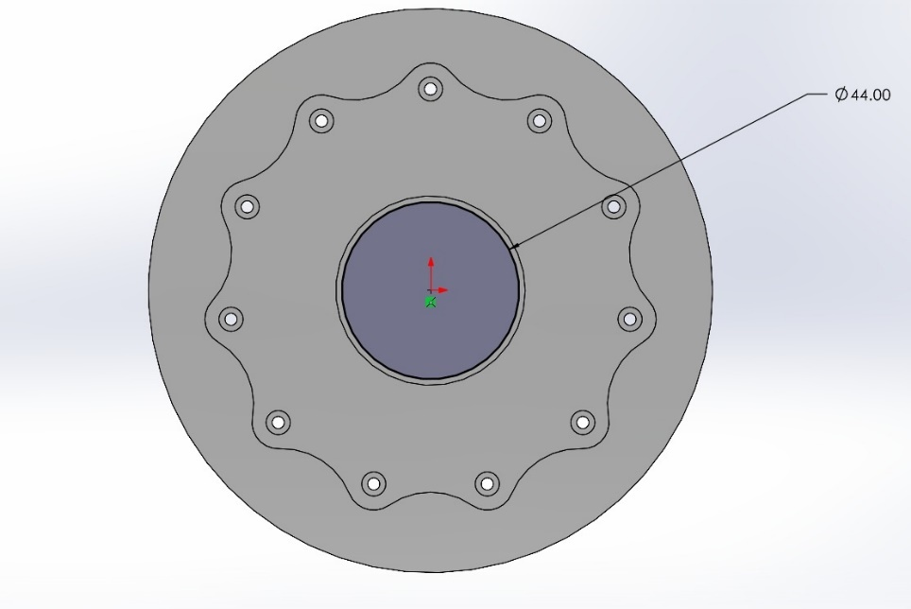

**Fig No. 4.3**

# 4. Input Flange.

# The input flange in a cycloidal drive is a critical component that facilitates the transfer of input power into the drive's internal mechanism. Positioned at the end of the input shaft, it acts as the connection point for motors or other power sources, ensuring a seamless integration into the overall system.

# When the input flange rotates, it drives an eccentric bearing or cam mounted on the input shaft. This action generates the characteristic cycloidal motion that is fundamental to the operation of the cycloidal drive.

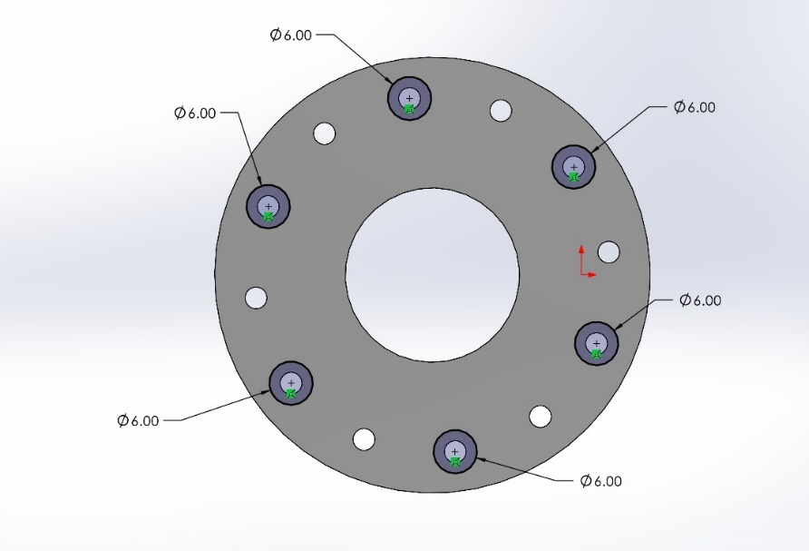5. Eccentric Cams.

**Fig No. 4.4**

These Cams are used to convert rotary motion or rotational motion into linear reciprocating motion.

The eccentric cam in a cycloidal gear drive causes the Cycloidal Disc to rotate in an Eccentric pattern which generally engages the ring-gear housing’s internal teeth.

These cams are designed by having an outer diameter of 24mm, inner diameter of 15mm with holes of 2.7mm and the eccentricity of 2mm.

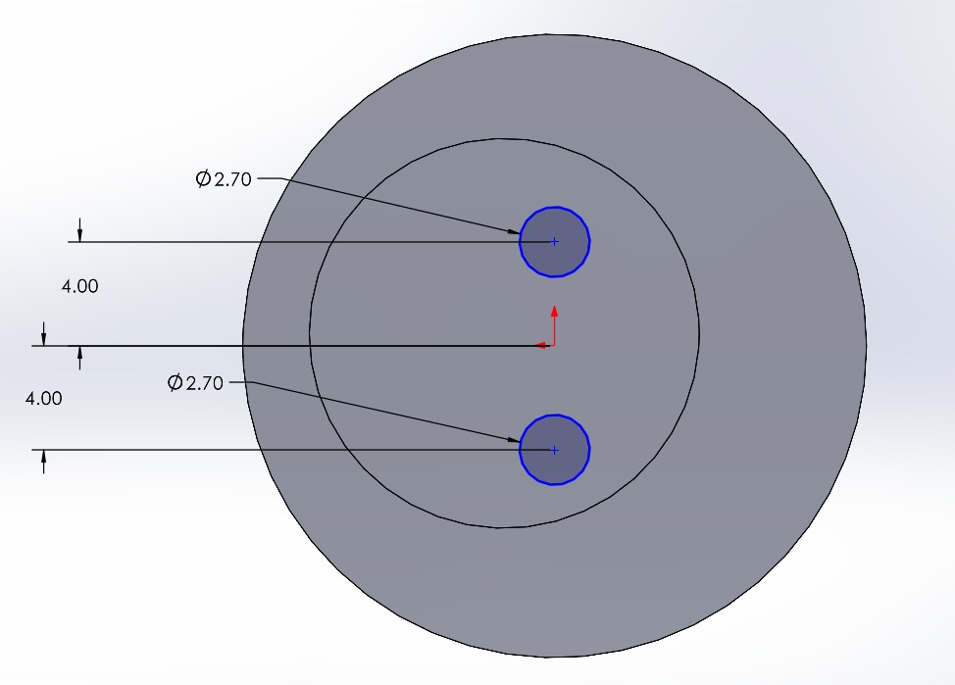

**Fig No. 4.5**

6. Output Flange.

The output flange in a cycloidal drive plays a crucial role in transferring the amplified torque produced by the cycloidal mechanism to the connected load. This component is strategically located at the output end of the drive, functioning as the interface between the drive system and external machinery.

In the cycloidal drive mechanism, the input shaft initiates an **eccentric motion** that drives a **cycloidal disc**. This disc interacts with fixed pins or rollers, translating the eccentric motion into rotational output. The output flange is integral in collecting this rotational motion and transmitting it to external systems, ensuring that the torque produced is effectively utilized.

# 

# Fig No. 4.6

7. Intermediate Cam.

The **intermediate cam**, is an essential component in a cycloidal drive, enabling the unique motion transformation that underpins the drive's functionality. This cam is mounted on an eccentric bearing connected to the input shaft, allowing it to trace a controlled cycloidal path as the input shaft rotates. Its specially designed profile, characterized by lobes or cycloidal curves, interacts with stationary pins or rollers within the housing, effectively constraining and guiding its movement.

During operation, the intermediate cam engages with output pins or rollers, facilitating the transfer of force and motion to the output flange. The design and number of lobes on the cam are critical, as they directly affect the reduction ratio of the drive; a higher lobe count allows for greater speed reductions in a compact configuration.

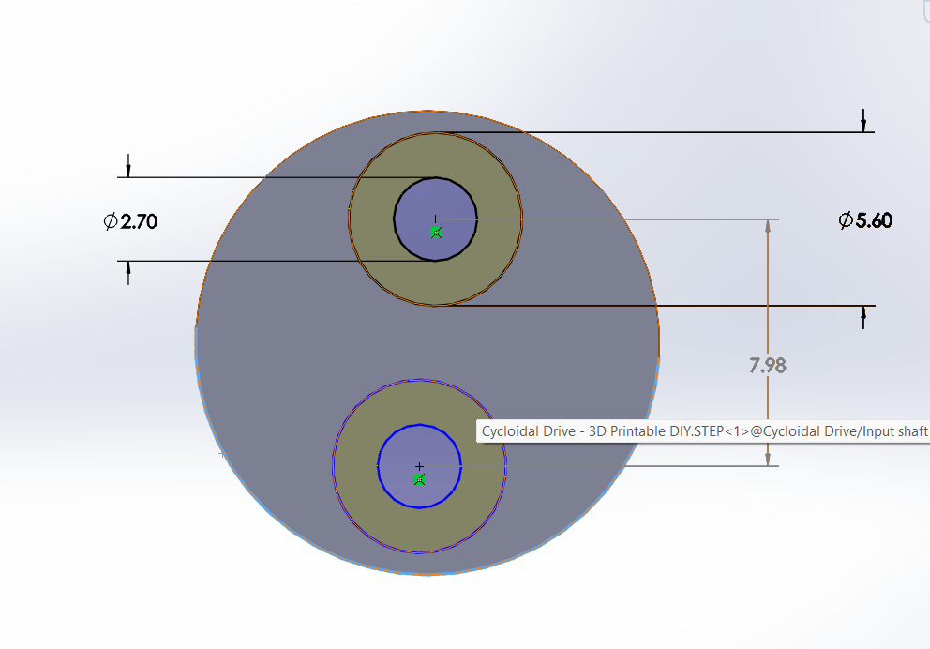

**Fig No. 4.7**

8. Screws

Screws are the mechanical components that joins two or more objects together, either permanently or temporarily.

The main type of Fasteners that are used here are Allen Key Cap Fasteners.

1. M3x8 Screws.

These Screws usually have diameter of 3mm and length of 8mm. These are mainly used in the input shaft of the motor.

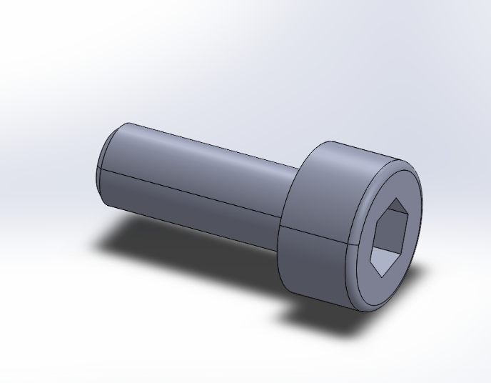

# Fig No. 4.8.1

# M3x20 Screws.

# These Screws have diameter of 3mm and length of 20mm. These are used in the intermediate disc and input flange.

**Fig No. 4.8.2**

1. M3x50 Screws.

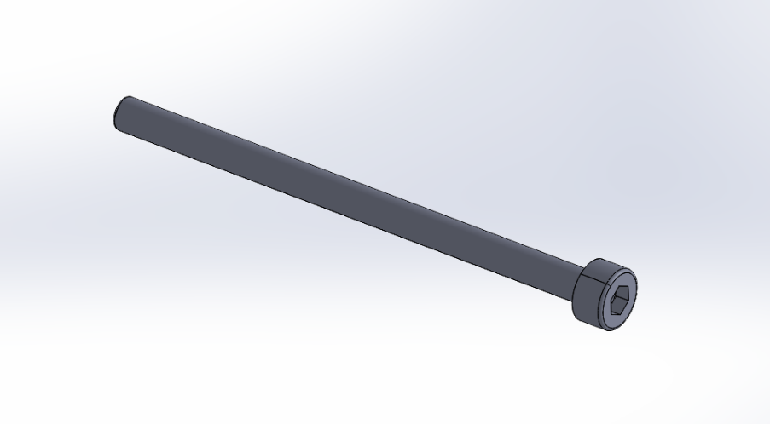These Screws have diameter of 3mm and length of 50mm. These are generally used in screwing the Casing and in connecting the Eccentric Cams.

**Fig No. 4.8.3**

# 9. Bearings.

# Bearings are the crucial components that serve a crucial role in rotating shafts and absorb the friction between the moving box within a gear drive.

# They facilitate smooth motion and transfer of power while withstanding significant loads that too in any harsh operating conditions. The type of bearings used here are Ball Bearings, as they are economical and produce smooth motion.

# *Ball Bearing -6802*

# These bearings have inner diameter of 15mm, outer diameter of 24mm and the thickness of

# 5mm. These are represented by 15x24x5.

# Bearing life-

# C-Dynamic Load, L-Life, Fr- Radial Load, Fa-Axial Load, X- Radial Load Factor, Y- Axial Load Factor.

# ID= 15mm OD=24mm B=5mm

# P= X. Fr + Y. Fa ------------(4.3)

# L=(C/P)3x1000000 revolutions

# Assuming : C=2000N, Co=800N, Fr=500N, Fa=200N

# X=1 , Y=0.56

# LOAD.

# P= X. Fr + Y. Fa Fig No. 4.9.1

# P=(1x500)+(0.56x200) = 500+112 = 612N

# Life in Million Cycles.

# L=(C/P)3x1000000

# C=2000N, P=612N

# L=(2000/612)3x1000000

# (3.267)3x1000000

# L=34.896 million cycles or 35 million cycles.

1. *Ball Bearing -686zz*

# These bearings have inner diameter of 6mm, outer diameter of 13mm and the thickness of

# 5mm. These are represented by 6x13x5.

# Bearing Life-

# C-Dynamic Load, L-Life, Fr- Radial Load, Fa-Axial Load, X- Radial Load Factor, Y- Axial Load Factor.

# ID=6mm OD=13mm B=5mm

# Assuming : C=400N, Co=155N, Fr=150N, Fa=50N

# X=1 , Y=0.56

# LOAD.

# P= X. Fr + Y. Fa

# P=(1x150)+(0.56x50) = 150+28 = 178N

# b) Life in Million Cycles.

# L=(C/P)3x1000000

# C=400N, P=178N

# L=(400/178)3x1000000

# (2.24)3x1000000

# L=11.239 million cycles or 12 million cycles. Fig No. 4.9.2

# *Ball Bearing -6807*

# These bearings have inner diameter of 35mm, outer diameter of 47mm and the thickness of

# 7mm. These are represented by 35x47x7.

# Bearing Life-

# C-Dynamic Load, L-Life, Fr- Radial Load, Fa-Axial Load, X- Radial Load Factor, Y- Axial Load Factor.

# ID=35mm OD=47mm B=7mm

# Assuming : C=4000N-5300N, Co=3000N, Fr=1000N, Fa=400N

# X=1 , Y=0.56

# 

# a) LOAD.

# P= X. Fr + Y. Fa

# P=(1x1000)+(0.56x400) = 1000+224 = 1224N

# b) Life in Million Cycles.

# L=(C/P)3x1000000

# C=4000N, P=1224N Fig No. 4.9.3

# L=(4000/1224)3x1000000

# (3.26)3x1000000

# L=34.64 million cycles or 35 million cycles.

# *Ball Bearing -6816*

# These bearings have inner diameter of 80mm, outer diameter of 100mm and the thickness of

# 10mm. These are represented by 80x100x10.

# Bearing Life-

# C-Dynamic Load, L-Life, Fr- Radial Load, Fa-Axial Load, X- Radial Load Factor, Y- Axial Load Factor.

# ID=80mm OD=100mm B=10mm

# Assuming : C=12800N, Co=8200N

# X=1 , Y=0.56

# Fr= 0.8x12800 = 10240N

# Fa= 0.3x10240 = 3072N

# 

# a) LOAD.

# P= X. Fr + Y. Fa

# P=(1x10240)+(0.56x3072) = 10240+1720.32 = 11960.32N

# b) Life in Million Cycles.

# L=(C/P)3x1000000

# C=12800N, P=11960.32N

# L=(12800/11960.32)3x1000000

# (1.07)3x1000000

# L=1.22 million cycles or 3 million cycles. Fig No. 4.9.4

# 10. Roller Pins.

# In a dual-stage cycloidal gear drive, rolling pins serve as critical components that facilitate the transfer of force between the cycloidal disc and the output mechanism. They are positioned along a circular path (the pin circle) and interact with the lobes or profiles of the cycloidal disc. As the cycloidal disc rotates eccentrically, it exerts force on the rolling pins, which convert this motion into rotational torque at the output. Unlike sliding contacts, the rolling action of these pins reduces friction and wear, enhancing the efficiency and longevity of the gear system.

# In operation, the load on each rolling pin depends on the input torque, the radius of the pin circle, and the number of pins. Proper design ensures that the force is evenly distributed across all pins to prevent overloading. The smooth engagement of the rolling pins with the cycloidal disc minimizes vibration and ensures consistent performance, even under heavy loads. These pins are typically made from

# hardened materials or include bushings to withstand repeated contact forces, ensuring durability and reliable performance in high-precision applications such as robotics, conveyors, and industrial machinery.

# Fig. No. 4.10

# CHAPTER-5

# 

# 5.1 Analysis Process Overview

# The analysis process in engineering design, particularly using tools like SolidWorks, involves several critical steps aimed at ensuring that a part or assembly performs as expected under various conditions. Below is a detailed breakdown of each step in the analysis process:

# *1. Prepare the Model*

# This foundational step ensures that the part or assembly is ready for analysis.

# Complete and Error-Free Geometry: Accurate geometry is crucial for realistic simulation results. Gaps or irregularities can lead to errors during meshing or analysis.

# Simplify the Model: Remove unnecessary features (e.g., small fillets, holes) to reduce computational load and speed up simulations without significantly compromising accuracy.

# *2. Access Simulation Tools*

# Simulation tools are not active by default in SolidWorks. You must enable the Simulation Add-In to access the necessary toolbar for setting up and performing analyses.

# *3. Set Up a New Study*

# The type of study you choose dictates the kind of analysis performed:

# Static Analysis: Assesses how a structure behaves under steady loads without time-dependent changes.

# Thermal Analysis: Investigates heat transfer and temperature distribution within the model.

# Frequency Analysis: Identifies natural frequencies and mode shapes of a structure.

# *4. Define Material Properties*

# Material properties such as density, elasticity, and thermal conductivity are essential for accurate simulation results. Selecting materials from a library ensures that real-world material behavior is accurately represented in the analysis.

# *5. Apply Fixtures (Boundary Conditions)*

# Fixtures simulate real-world conditions by defining how the part is held or constrained during analysis:

# Fix one face to replicate a clamped boundary.

# Allow only specific movements or rotations to reflect actual operational constraints.

# *6. Apply Loads*

# Loads represent external forces, pressures, or environmental effects acting on the part:

# Forces: Push or pull actions applied to surfaces.

# Pressure: Distributed forces acting uniformly over a surface.

# *7. Mesh the Model*

# Meshing divides the model into smaller finite elements for numerical computation:

# A finer mesh increases accuracy but requires more computational resources.

# Areas with high stress or complex geometry may require mesh refinement to ensure accurate results.

# *8. Run the Analysis*

# Once the model setup is complete, execute the simulation. SolidWorks computes how the part or assembly behaves based on the defined inputs, solving equations related to stress, displacement, and other parameters.

# *9. Review Results*

# After running the simulation, results can be visualized through various plots and graphs:

# Stress Plot: Identifies areas of high stress, indicating potential failure points.

# By carefully analyzing these visualizations, you can identify design weaknesses or validate that the part meets performance requirements under specified conditions. This structured approach ensures thorough analysis and helps engineers make informed decisions in their design processes.

# 5.1.1 Parts Analysis

# Cycloidal Discs.

# Maximum Stress: 4.354x105 N/m2

# Minimum Stress: 3.188x102 N/m2

# Fig. No. 5.1.1

# 

# Intermediate Disc.

# Maximum Stress: 2.912x105 N/m2

# Minimum Stress: 1.028x104 N/m2

# 

# Fig. No. 5.1.2

# 

# 

# Casing.

# Maximum Stress: 5.364x105 N/m2

# Minimum Stress: 5.055x103 N/m2

# Fig. No. 5.1.3

# 

# Input Flange.

# Maximum Stress: 1.843x106 N/m2

# Minimum Stress: 4.808x104 N/m2

# 

# Fig. No. 5.1.4

# Eccentric Cams.

# Maximum Stress: 4.695x105 N/m2s

# Minimum Stress: 6.977x102 N/m2

# 

# Fig. No. 5.1.5

# 

# Output Flange.

# Maximum Stress: 3.562x105 N/m2

# Minimum Stress: 7.251x102 N/m2

# Fig. No. 5.1.6

# Ball Bearings Used

# 6802

# Maximum Stress: 2.643x106 N/m2

# Minimum Stress: 1.072x106 N/m2

# 

# Fig. No. 5.1.7(a)

# 686zz

# Maximum Stress: 5.062x106 N/m2

# Minimum Stress: 1.110x106N/m2

# Fig. No. 5.1.7(b)

# 6807

# Maximum Stress: 1.182x10-4 N/m2

# Minimum Stress: 1.107x10-6N/m2

# Fig. No. 5.1.7(c)

# 5.2 Manufacturing

# 1. Concept and Design

# The initial step is to clearly identify the purpose of the part and its requirements. This includes:

# Size: Dimensions of the part, ensuring it fits within the 3D printer’s build volume.

# Strength: Mechanical properties based on the part’s intended use (e.g., durability, flexibility).

# Material: Selection of material (e.g., PLA, ABS, PETG) suited to the functional and aesthetic needs.

# a) Design in SolidWorks or Similar Software

# Use Designing software such as SolidWorks, Fusion 360, or Blender to create a 3D model.

# Ensure the model is "watertight", meaning the mesh has no gaps, holes, or intersecting geometry that could lead to errors during printing.

# b) Optimize the Model for Printing

# Avoid unnecessary overhangs or complex geometries that may require excessive support structures.

# Consider the printer’s capabilities, such as layer height and resolution, during the design phase.

# 2. Prepare the Model

# a) Export the file

# Save the 3D model in a printable format such as .STL or .OBJ to maintain compatibility with slicing software.

# b) Check for Errors

# Use software like Meshmixer or Netfabb to inspect and repair the model.

# Look for issues such as inverted normals or non-manifold edges.

# c) Slice the Model

# Import the file into slicing software like Cura, PrusaSlicer, or Simplify3D.

# Set printing parameters:

# Layer Height: Determines the resolution and surface finish.

# Infill Density: Balances strength and material usage.

# Print Speed: Optimized based on material and printer capabilities.

# Supports: Generate supports for overhangs or complex geometries.

# Generate G-code, which contains the instructions for the printer.

# 3. Prepare the Printer

# a) Choose the Right Material

# Select a filament or resin that suits the design requirements. Examples include:

# PLA: Easy to print, good for general-purpose parts.

# ABS: Durable and heat-resistant but requires controlled conditions.

# PETG: Combines strength, flexibility, and ease of printing.

# b) Load the Filament/Resin

# For FDM printers, insert the filament into the extruder.

# For SLA/DLP printers, pour resin into the vat, ensuring it is free from debris.

# c) Level the Bed

# Ensure the print bed is clean and properly levelled for optimal first-layer adhesion.

# d) Preheat the Printer

# Set the appropriate nozzle and bed temperatures for the selected material.

# 4. Printing

# a) Start the Print

# Transfer the G-code file to the printer via SD card, USB, or Wi-Fi.

# Begin the print and monitor the process.

# b) Monitor the Process

# Pay close attention to the initial layers to ensure proper adhesion and alignment.

# Address issues such as warping, stringing, or uneven extrusion if they arise.

# 5. Post-Processing

# a) Remove the Print

# Detach the finished part from the build plate carefully using tools like a scraper.

# For SLA prints, handle with care to avoid smudging uncured resin.

# b) Clean the Part

# Remove excess material, supports, or rafts.

# For resin prints, wash the part in isopropyl alcohol and cure under UV light.

# c) Finishing Touches

# Apply sanding, painting, or polishing as needed to achieve the desired surface finish.

# 6. Testing and Iteration

# a) Test the Part

# Evaluate the part’s performance against functional and aesthetic criteria.

# Check for dimensional accuracy, strength, and overall quality.

# b) Adjust if Needed

# Make necessary changes to the design or print settings based on testing outcomes.

# Repeat the printing process if required to achieve the desired result.

# *5.2.1 3-D Printed Parts*

# 1. Cycloidal Discs

# Time taken to print each Discs: 1 hour 32 minutes

# 

# 

# Fig. No. 5.2.1

# 2. Intermediate Disc.

# Time taken to print Intermediate Discs: 1 hour 5 minutes

# 

# 

# Fig. No. 5.2.2

# 3. Casing

# Time taken to print Casing: 6 hours 30 minutes

# 

# Fig. No. 5.2.3(a) Fig.No. 5.2.3(b)

# 4. Input Flange

# Time taken to print Input Flange: 45 minutes

# 

# Fig. No. 5.2.4

# 5. Eccentric Cams

# Time taken to print Eccentric Cams: 35 minutes

# 

# Fig. No. 5.2.5

# 6. Output Flange.

# Time taken to print Output Flange: 3 hours 10 minutes

# Fig. No. 5.2.6

# 7. Intermediate Cam.

# Time taken to print Intermediate Cam: 25 minutes

# 

# 

# Fig. No .5.2.7

# 5.3 Iterations

# 1. I Iteration 2. II Iteration

# Offset= 6.5mm Offset= 6.5mm

# Eccentricity= 2.5mm Eccentricity= 2mm

# 

# Fig. No. 5.3.1 Fig. No. 5.3.2

# 3. III Iteration 4. IV Iteration

# Offset= 6.72 mm Offset= 6.75mm

# Eccentricity= 2mm Eccentricity= 2mm

# 

**Fig. No. 5.3.3 Fig. No. 5.3.4**

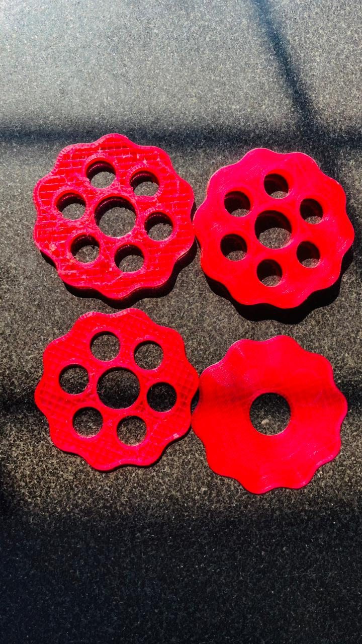

` **Fig. No. 5.3.5**

**CHAPTER-6**

**6.1- Results**

For Reduction Ratio of 1:100,

Initial Speed of Motor=3000 rpm

Initial Torque of motor= 4.2 kg-cm = 0.4118 Nm

*For Stage I reduction,*

The Reduction Ratio is 1:10,

So the reduction in speed = 3000/10 = 300 rpm

Torque Increment = 0.4118x10= 4.118 Nm

*For Stage II reduction,*

The Reduction Ratio is 1:10

So the reduction in speed = 300/10 = 30 rpm

Torque Increment = 4.118x10 = 41.18 Nm = 419.919 kg cm

**6.2- CONCLUSION**

From this Dual-stage Cycloidal Gear Drive we can conclude that

* The reduction of speed is evenly reduced across both the stages.
* The torque is incremented evenly across both the stages.
* The design is compact and easy to handle.
* Instead of 3-D printing, we can consider CNC Machining for manufacturing.

**6.3- FUTURE SCOPE**

Advanced Materials Integration: The development and application of stronger and more durable 3D printing materials, such as carbon-fibre-reinforced polymers or metal composites, will enable cycloidal gear drives to handle higher loads and operate in more demanding environments.

Hybrid Manufacturing Techniques: Combining 3D printing with traditional manufacturing methods, such as CNC machining for critical components, can enhance precision and durability while maintaining cost-effectiveness for low-volume production.

Miniaturization for Specialized Applications: Enhanced precision in 3D printing will facilitate the production of compact cycloidal gear drives suitable for small-scale robotics, medical devices, and wearable technologies requiring high precision and reliability**.**

Smart and Embedded Sensors: Future designs can incorporate embedded sensors during the 3D printing process for real-time monitoring of torque, load distribution, and wear, enabling predictive maintenance and enhanced performance.

Mass Customization and Prototyping: The flexibility of 3D printing allows for the rapid customization of cycloidal gear drives for specific industries, such as aerospace, automotive, and renewable energy, reducing lead times and development costs.

Sustainability and Recycling: Using recyclable materials or bio-based filaments in 3D printing can contribute to more sustainable manufacturing practices, aligning with global efforts to reduce industrial waste.

# 6.4- BILL OF MATERIALS.

|  |  |  |  |
| --- | --- | --- | --- |
| **Sl. No.** | **Components** | **Quantity** | **Price in Rupees** |
| 1. | PETG Material | 2 | 2400 |
| 2. | 6802 Ball Bearing | 8 | 400 |
| 3. | 686zz Ball Bearing | 68 | 4080 |
| 4. | 6807 Ball Bearing | 1 | 145 |
| 5. | 6816 Ball Bearing | 1 | 510 |
| 6. | M3x8 Screw | 4 | 20 |
| 7. | M3x20 Screw | 20 | 120 |
| 8. | M3x50 Screw | 4 | 60 |
| 9. | Miscellaneous | - | 300 |
|  | TOTAL EXPENDITURE | | 8035 Rupees |

**Table No. 6.4.1**

**6.5- Advantages**

1. High Reduction Ratios

Dual-stage cycloidal gearboxes can achieve extremely high reduction ratios in a compact size. This is ideal for applications requiring precise speed reduction without increasing the gearbox's overall footprint.

2. Compact and Lightweight Design

Despite providing high reduction ratios, dual-stage cycloidal gearboxes are compact and lightweight, which allows for easy integration into machinery without adding significant bulk or weight.

3. High Efficiency and Torque Transmission

These gearboxes have high torque transmission capabilities with minimal energy loss. The rolling and pin engagement mechanism ensures efficient power transfer with reduced friction and wear.

**6.6- Disadvantages**

1. Complex Manufacturing

The intricate design and precision required for cycloidal discs, pins, and other components make manufacturing more complex and costly compared to conventional gearboxes.

2. Higher Initial Cost

Due to the complexity of design and materials used, the upfront cost of dual-stage cycloidal gearboxes is typically higher than standard gearboxes like planetary or helical types.

3. Installation Complexity

Proper alignment and precision are required during installation. Misalignment or improper assembly can lead to reduced performance, excessive wear, or damage over time.

**REFERENCES.**

* <https://www.researchgate.net/publication/349799056_Computational_studies_on_cycloidal_gearboxes_a_systematic_literature_review>
* <https://www.sciencedirect.com/science/article/abs/pii/0094114X9090064Q?via%3Dihub>
* <https://doi.org/10.1115/1.4004540>
* <https://www.researchgate.net/publication/381708630_Design_and_Development_of_Cycloidal_Gear_Box>
* <https://www.researchgate.net/publication/235992854_A_New_Design_of_a_Two-Stage_Cycloidal_Speed_Reducer>
* chrome-extension://efaidnbmnnnibpcajpcglclefindmkaj/https://hrcak.srce.hr/file/302795?utm_source
* <https://journals.sagepub.com/doi/abs/10.1177/0954406215618984?utm_source>
* <https://www.researchgate.net/publication/262341102_Design_of_a_two-stage_cycloidal_gear_reducer_with_tooth_modifications>
* chrome-extension://efaidnbmnnnibpcajpcglclefindmkaj/https://gearkade.com/Gearkade%20content/Books/Handbook-Gear-Design-Maitra-2nd-Ed.pdf?